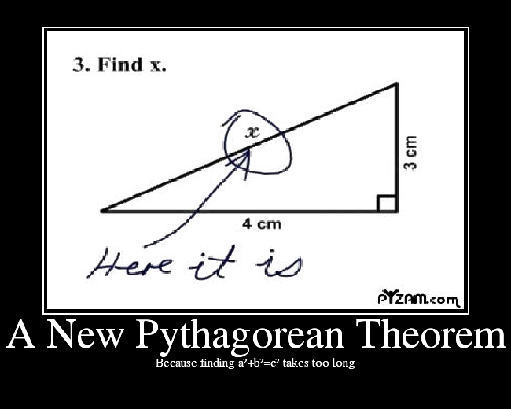

# **Lesson Objectives**

1. Overview of The Pythagorean Theorem
2. Solve problems related to The Pythagorean Theorem

# Overview of **The Pythagorean Theorem**

Do you recall how **The Pythagorean Theorem** goes?

But what does it mean? What are $a, b, and c$?

What is needed for The Pythagorean Theorem to work?

This formula, $a^{2}+b^{2}=c^{2}$, makes little sense without some context.

The Pythagorean Theorem applies to **__________________triangles** only, not all triangles.

Sides ***a*** and ***b*** are called **______________**, and they come together to form the right angle.

The legs *a* and *b* are arbitrary – either one could be the shorter side (or the same length).

Side ***c*** is called the **______________________**, and it is always the **___________________** side, opposite the right angle.

# **Solve Problems** Related to The Pythagorean Theorem

## **Hypotenuse** is unknown

* **EXAMPLE:** The lengths of the legs of a right triangle are given. Find the hypotenuse.

*a* = 24, *b* = 45 [R.1.27]

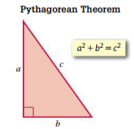

Using The Pythagorean Theorem, $a^{2}+b^{2}=c^{2}$ (easier to reverse it)

${c^{2}=a}^{2}+b^{2}$ Plug in the values for *a* and *b*

${c^{2}=( )}^{2}+{( )}^{2}$ Simplify

$c^{2}= +$ Simplify

$c^{2}=$ Square root both sides

Use calculator

$c=$

## One of the **Legs** is unknown

* **EXAMPLE:** Find the value of *x*. [*PHG 8.1.17]

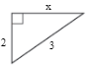(Simplify your answer. Type exact answer, using radicals as needed.)

It may be very tempting to just glance at this triangle and say *x* = 1.

Try again…resist that temptation!

This is a right triangle, so we’ll use The Pythagorean Theorem, $a^{2}+b^{2}=c^{2}$.

$a^{2}+b^{2}=c^{2}$

Common error is: ${(2)}^{2}+{(3)}^{2}=x^{2}$

Subtract ______ from both sides

Combine like terms and simplify

Square root both sides

Simplify the square root, if needed.

Common error is: $x=5$

* **EXAMPLE:** Find the value of *x*. If necessary, write your answer in simplest radical form.

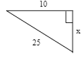[*Martin-Gay 9.1.9]

This is a right triangle, so we’ll use

The Pythagorean Theorem, $a^{2}+b^{2}=c^{2}$.

$a^{2}+b^{2}=c^{2}$

Common error is ${(10)}^{2}+{(25)}^{2}=x^{2}$

Subtract 100 from both sides

Combine like terms and simplify

Square root both sides

Simplify the square root

Sources Used:

1. MyLab Math for *Geometry*, Martin-Gay, Pearson Education Inc.
2. MyLab Math for *Prentice Hall Geometry*, ©2011, Pearson Education Inc.
3. MyLab Math for *College Algebra with Modeling and Visualization*, 6th Edition, Rockswold, Pearson Education Inc.
4. Wabbitemu calculator emulator version 1.9.5.21 by Revolution Software, BootFree ©2006-2014 Ben Moody, Rom8x ©2005-2014 Andree Chea. Website <https://archive.codeplex.com/?p=wabbit>